**Experiment: 04**

**Date: 13.04.2022**

**Program Name:**

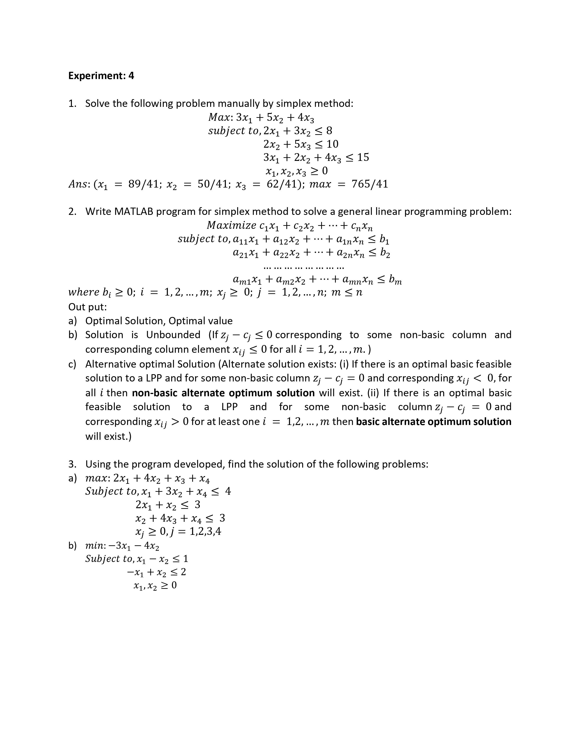

**Simplex Algorithm:**

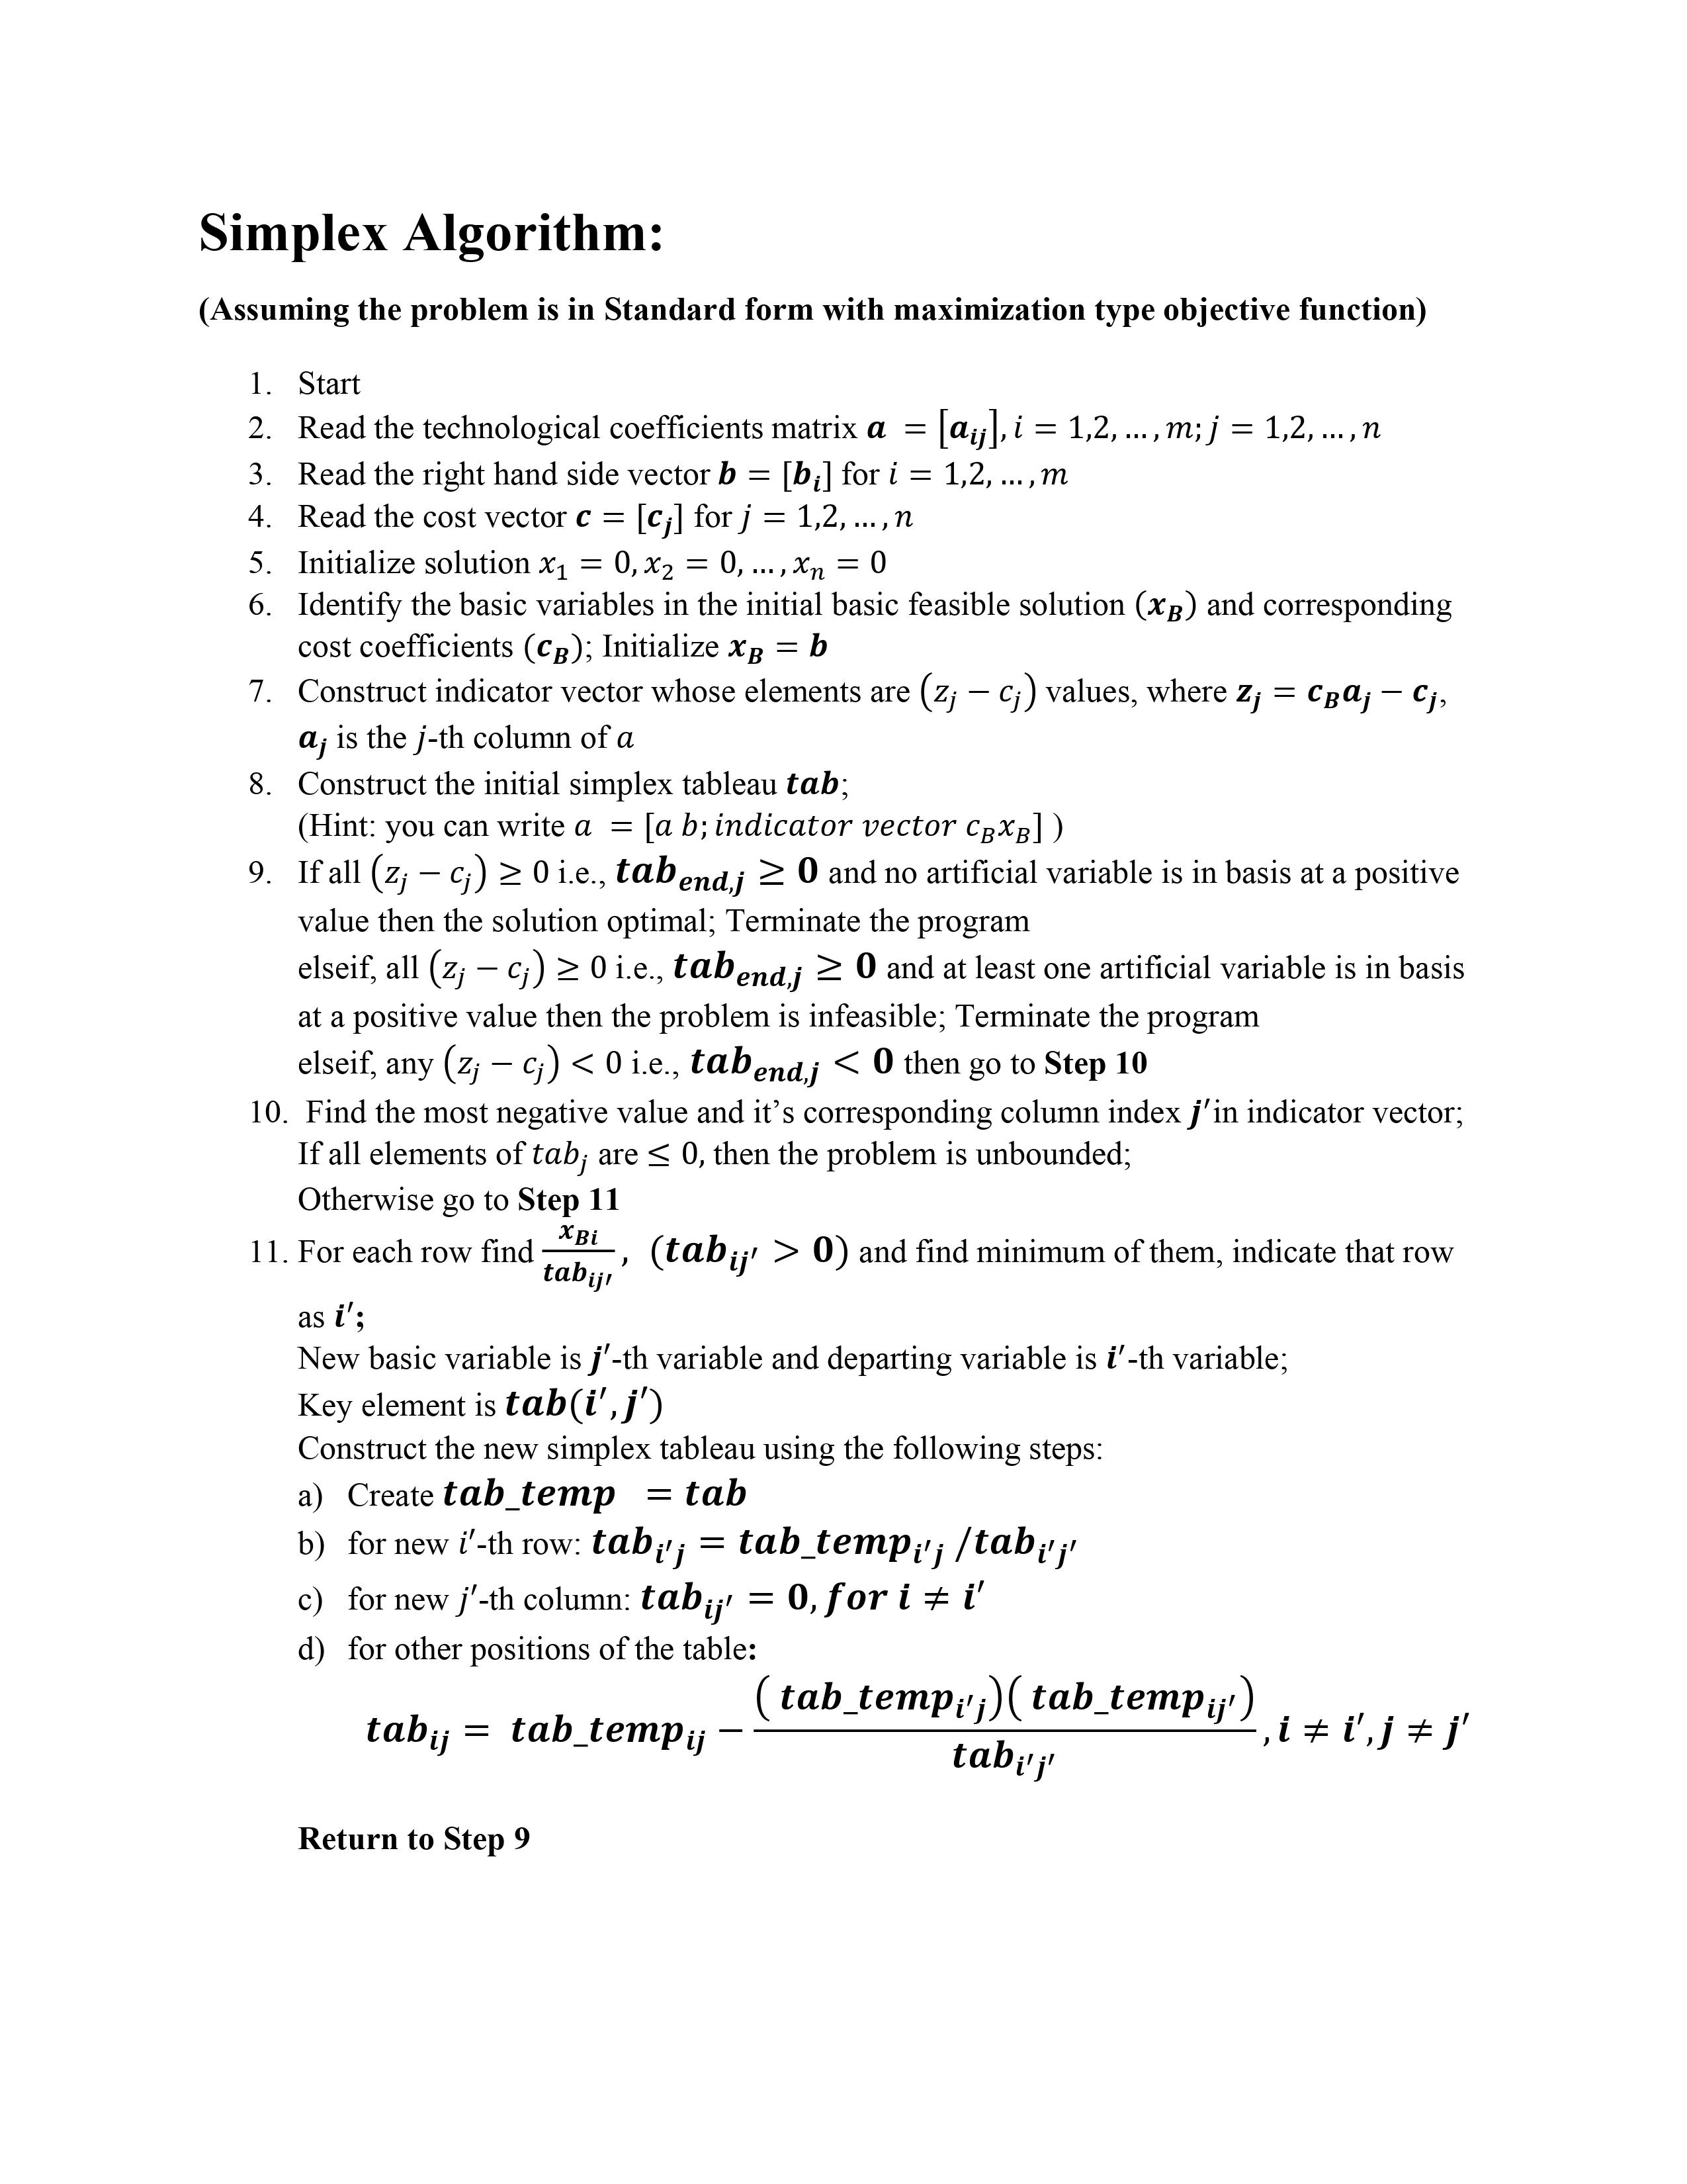

**Simplex Flowchart:**

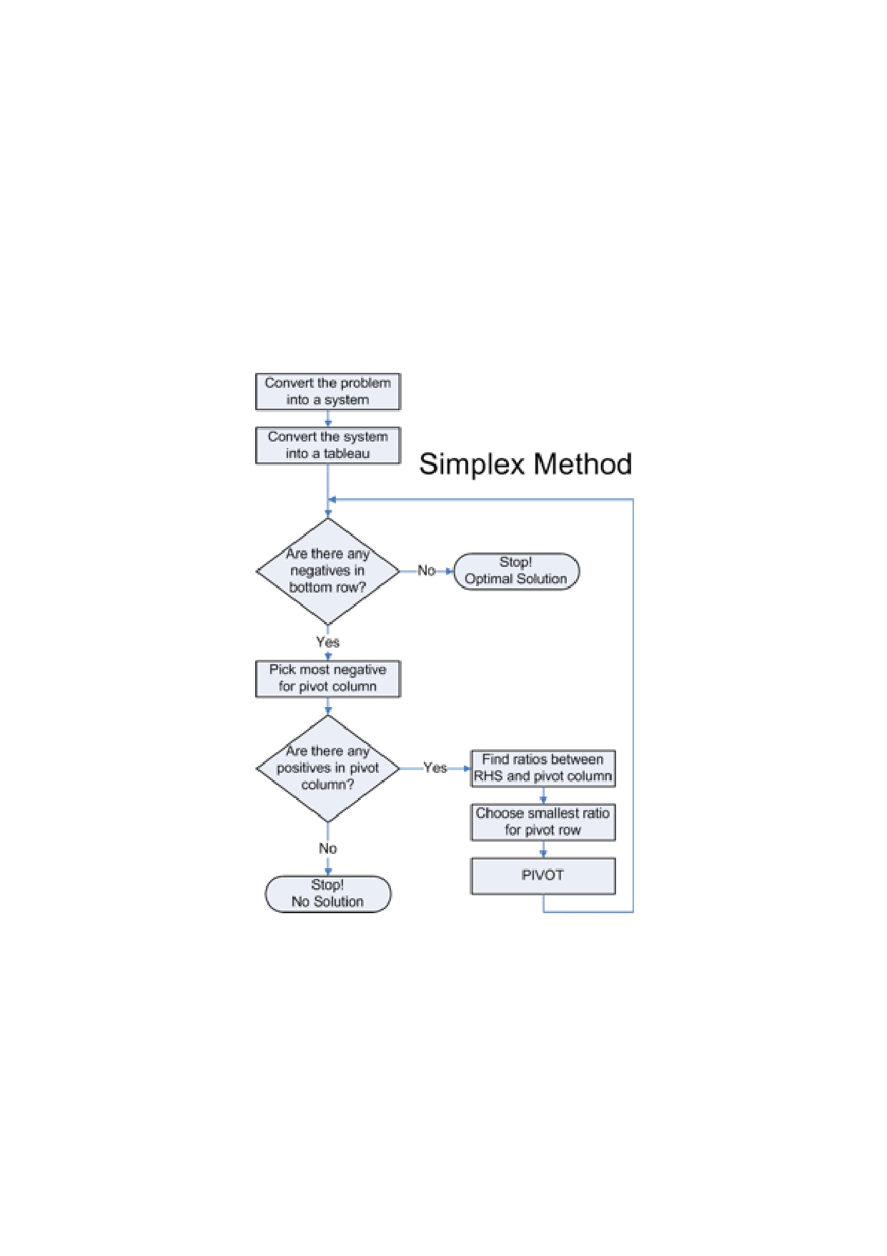

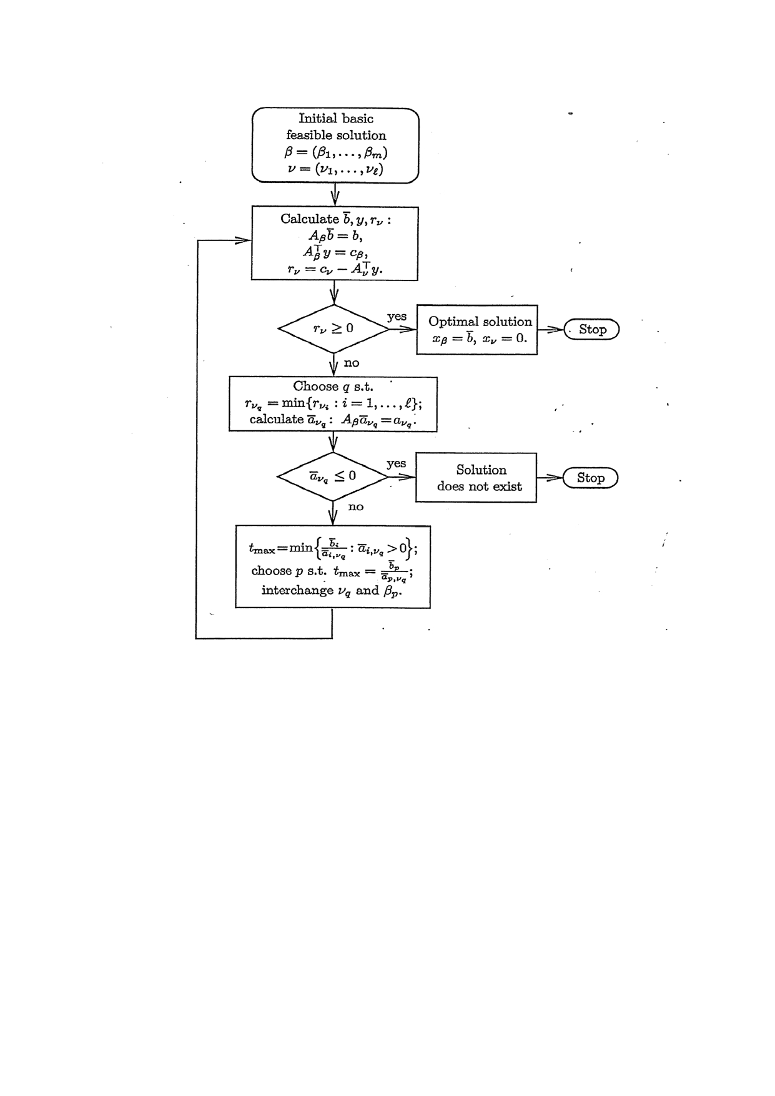

**2. Program Code :( Write MATLAB program for simplex method to solve a general linear programming problem:)**

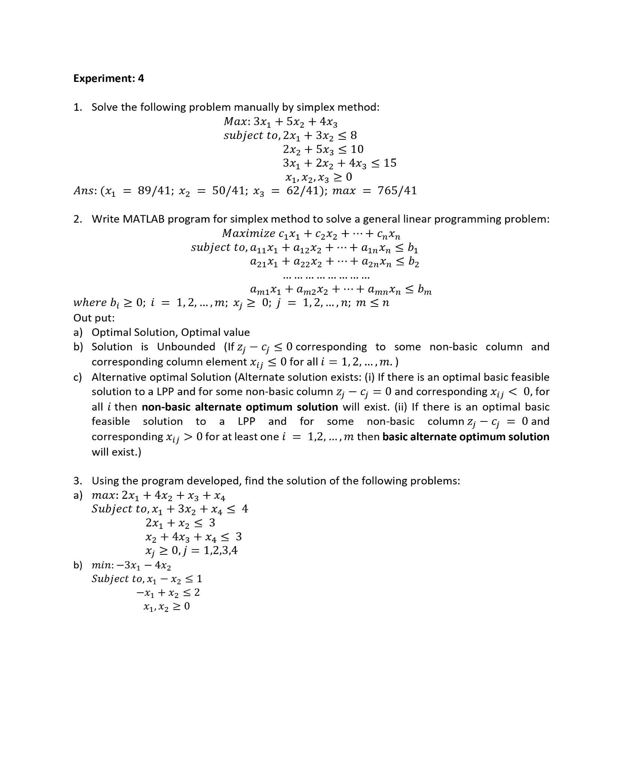

**Program Code:**

**%ANINDYA NAG**

**%UG/02/BTCSE/2018/005**

**clc;**

**clear all;**

**%This program is for solving problems on the simplex method**

**%where the problem is maximization type and all the constraints are less than equal (<= ) type.**

**m=input('How many constraints?\n');**

**n=input('How many variables?\n');**

**c_nb=input('Enter the cost vector: ');**

**for j=1:n**

**%c_nb(j,1)=input('');**

**xnb_ind(1,j)=j;**

**x(j,1)=0;**

**end**

**b=input('Enter the right hand side vector: ');**

**for i=1:m**

**%b(i,1)=input('');**

**c_b(i,1)=0;**

**xb_ind(i,1)=n+i;**

**x(n+i,1)=0;**

**end**

**a=input('Enter the coefficient matrix: ');**

**% for i=1:m**

**% for j=1:n**

**% a(i,j)=input('');**

**% end**

**% end**

**x=zeros(n+m,1);**

**for j=1:n**

**indicator(1,j)=c_b'*a(:,j)-c_nb(j,1);**

**end**

**[ind,KC]=min(indicator);**

**tab_old=[a b; indicator c_b'*b];**

**while(ind < 0)**

**for i=1:m**

**if (tab_old(i,KC)>0)**

**ratio(i,1)=b(i,1)/tab_old(i,KC);**

**else**

**ratio(i,1)=10^6;**

**end**

**end**

**[min_ratio,KR]=min(ratio);**

**temp=xb_ind(KR,1);**

**xb_ind(KR,1)=xnb_ind(1,KC);**

**xnb_ind(1,KC)=temp;**

**if (min_ratio==10^6)**

**disp('Problem is unbounded');**

**else**

**KE=tab_old(KR,KC);**

**for i=1:m+1**

**for j=1:n+1**

**if (i==KR && j==KC)**

**tab_new(i,j)=1/KE;**

**elseif(i==KR)**

**tab_new(i,j)=tab_old(i,j)/KE;**

**elseif(j==KC)**

**tab_new(i,j)=-tab_old(i,j)/KE;**

**else**

**tab_new(i,j)=(KE*tab_old(i,j)-tab_old(KR,j)*tab_old(i,KC))/KE;**

**end**

**end**

**end**

**end**

**for i=1:m**

**x(xb_ind(i,1),1)=tab_new(i,n+1);**

**end**

**for j=1:n**

**x(xnb_ind(1,j),1)=tab_new(m+1,j);**

**end**

**tab_new;**

**indicator=tab_new(m+1,:);**

**[ind,KC]=min(indicator);**

**tab_old = tab_new;**

**end**

**x**

**Output :**

**For Question 1 :**



**Output:**

**How many constraints?**

**3**

**How many variables?**

**3**

**Enter the cost vector: [3;5;4]**

**Enter the right hand side vector: [8;10;15]**

**Enter the coefficient matrix: [2 3 0;0 2 5;3 2 4]**

**x =**

**2.1707**

**1.2195**

**1.5122**

**1.0976**

**0.5854**

**0.2683**

**>>**

**Conclusion :**

**We saw that, the solution we obtained by calculating manually by Simplex method and the solution we obtained by this program is the same.**

**And**

**The optimal solution:**

**3.( Using the program developed ,find the solution os the following problems:)**

**Output:**

**a) For,**



**Output:**

**How many constraints?**

**3**

**How many variables?**

**4**

**Enter the cost vector: [2;4;1;1]**

**Enter the right hand side vector: [4;3;3]**

**Enter the coefficient matrix: [1 3 0 1;2 1 0 0;0 1 4 1]**

**x =**

**1.0000**

**1.0000**

**0.5000**

**0.3500**

**1.1000**

**0.4500**

**0.2500**

**>>**

**The optimal solution:**

**Output:**

**b) For,**



**Output:**

**How many constraints?**

**2**

**How many variables?**

**2**

**Enter the cost vector: [3;4]**

**Enter the right hand side vector: [1;2]**

**Enter the coefficient matrix: [1 -1;-1 1]**

**Problem is unbounded.**